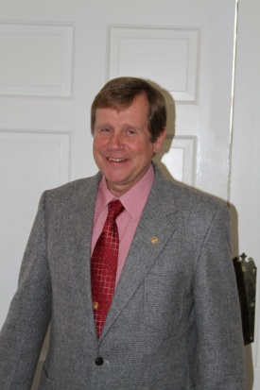

“It is with great pride and pleasure that I serve and represent the TWHBEA and the pleasure horse division as your Vice President.”

Rick began training and showing the pleasure Walking Horse in the early 70’s mostly in open all breed shows while in his early twenties. He owned and operated a training and show barn in Fort Wayne, Indiana, while earning a mechanical engineering degree, serving in the Army Reserve as a Drill Sergeant in an infantry training unit, working full time as a tool and die designer and beginning a family. In 1984 Rick and family moved to the west shore of Flathead Lake in Montana to take on the management, training and showing duties for the Dr. Taylor ranch were a broodmare band of twenty plus was formed. In 1995 Rick purchased the Montana Ranch and reestablished Rick Wies Stables, which he operates to date.

Rick has been elected to the TWHBEA international board of directors on six occasions and has actively served on virtually every divisional committee, with over eighty appointments. Rick first served on the pleasure horse committee in 1978 and as such was show chair for one of the very first national TWHBEA Heyday shows, and competes successfully in the versatility program. He has been President of the Central States and Montana Walking Horse Associations. Rick is well respected has a pleasure horse clinician and judge holding an AAAPVE license, has served on the TWHBEA speaker’s bureau and a “Walk this Way” clinician. Rick is currently serving his fifth term on the Executive Committee as Vice President Pleasure Division.

“It as been extremely rewarding for me to have been involved and to have witnessed the growth and popularity of the pleasure Walking Horse over the past forty years, be it the trail, the show ring, or one of the many other growing disciplines.”

RICK WIES
100% Commitment to TWHBEA
TWHBEA and Walking Horse Involvement

- Elected to 6 terms International board of Directors (IN and MT)
- 5 terms Executive Committee as Vice-President Pleasure
- Actively served on over 80 Executive Committee Assignments beginning with pleasure horse in 1978.
- Past President Central States WH Association (6 years)
- Past President Montana WH Association (4 years)
- Develop first youth Scholarship Program over $20,000 annually, chaired youth committee for several years and recommended establishment of VP youth position on EC.
- Numerous all breed, 4-H, Walking Horse board and Horse Show chair positions. (way too many too recall)
- Back Country of America member and participant.
- Proposed frozen semen certificate program and was issued the first 310 TWHBEA certificates for stallions collected in the 80’s.

RECENT PLEASURE HORSE ACCOMPLISHMENTS

- New rule book
- New versatility program
- New lifetime and yearly achievement level awards developed (Honor Roll, Honor of Merit and Register of Merit)
- Yearly award certificate and top ten high point program developed
- Versatility program points on IPEDS. (took 10 years)
- Added Elite Championship program
- Added Extreme Sport Division
- Invited Futurity and Open Show to coincide with the World Versatility
- Assistance for regional shows
- New versatility Supreme and Superior Champions digital display
- 3 Successful TWHBEA Extreme Cowboy Race Events
- The most growth ever at the WORLD VERSATILITY SHOW
(Three year growth from 250 entries to 557 entries)

RICK WIES FOR FAIRNESS, DIVERSITY, EXPERIENCE

